# Bug 2 – Debugging Log

Hypothesis 1:

|  |  |
| --- | --- |
| Hypothesis | Balance is calculated incorrect within Player.balanceExceedsLimitBy(int amount) has a logic error causing limit not to be reached |
| Prediction | Game ends before player reaches limit |
| Experiment | Run game and observe |
| Observation | Balance at end of game is 5 instead of 0 which is equal to bet amount and greater than bet limit |
| Conclusion | There is a logic error within Player.balanceExceedsLimitBy(int amount) method |

Bug Resolution:

To resolve the bug we need to check if the balance was not only greater than limit but also if it was equal to the limit which can be changed by changing the > operand to >= operand demonstrated in the before and after screenshots:

Before:

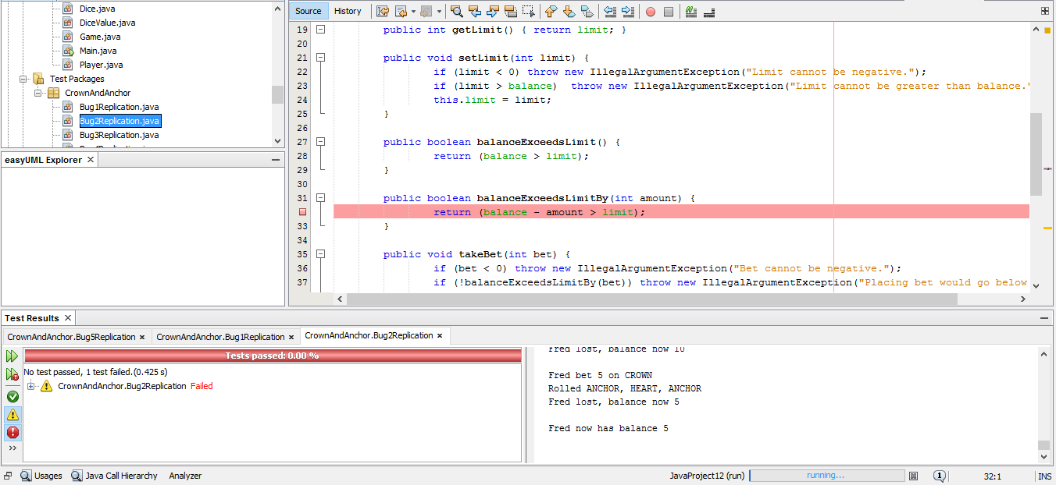

After: 